1. 200 Word Minimum Script (Written by the Script Writer) (Colter and Edgar)

You start out in a desolate forest filled only by the sound of birds and insects. It's bright and green as it shows a cabin, and a robot woodsman sawing down a tree out front. Looking around, the trees sway with the wind. Bored, the Woodsman gets curious, walking into the forest. The dirt and leaves crushing underneath its metal frame as it walks. It keeps going deeper and deeper into the forest seeing more and more decommissioned robots, logging robots like it is and it gets to a dirty broken road, seeing a billboard for its model of robot. It sees a logo for (???) the company that created it. Looking back at the direction of its cabin it looks down at its hands questioning its purpose for the first time. It decides to go out and try to find the company's home base to see if it can find out more about itself and to see if it can figure out what happened to humanity after the disease took over killing most of the population and turning the rest into messed up and gross monsters. But first it has to trek hundreds of miles firstly through the forest.

1. 6 Panel Minimum Storyboard/Design Concept (Created by the Graphics Designer) (Elliot and Finn)

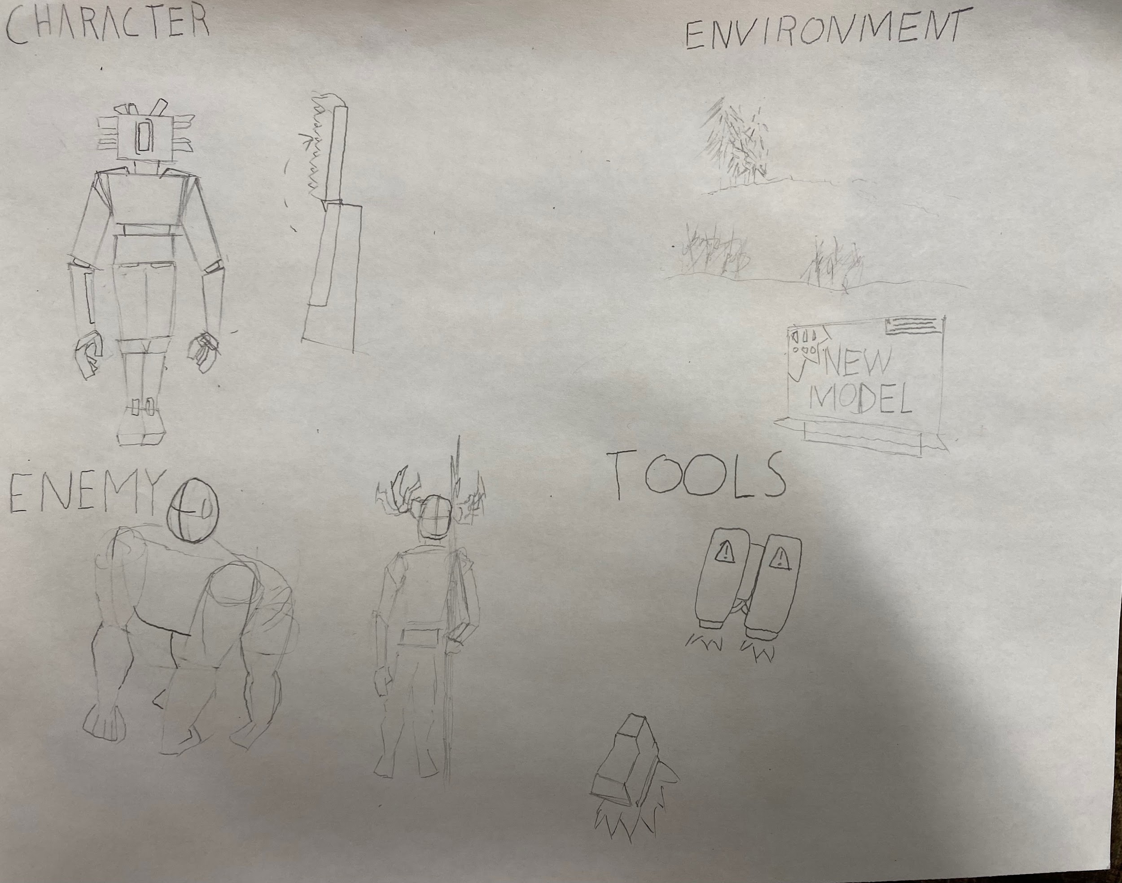

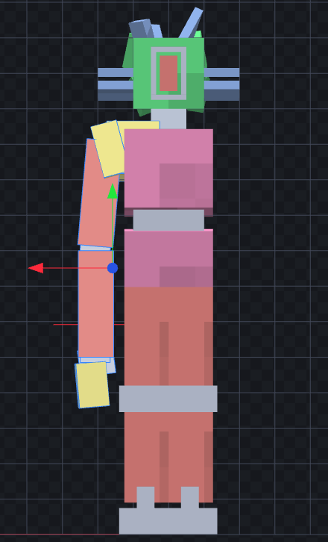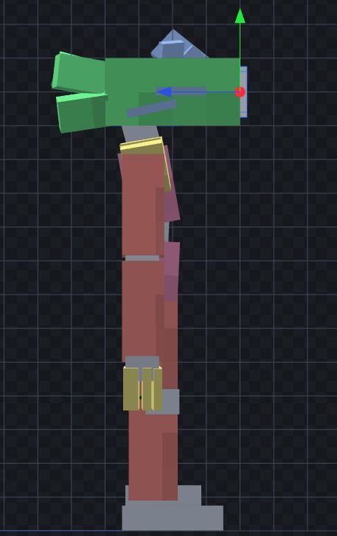

1. 1 Paragraph Engine Selection/Play Mechanics Plan (Chosen by Programmer 1) (Emil)

We are going to be using unity, mostly because that is what we have on these computers. The game will be mostly combat and exploration. Fighting will all be done with your fists, with the occasional bad long range item. Exploration will to find more abilities and weapons.

1. 1 Paragraph Game Goals: Level Planning/World Development (Defined by Script Writer and Programmer 1) (Emil and Colter)

The world is infected with some strange disease. Most of the humans are completely gone. The few that remain are being mutated by this disease. The animals are also being affected by this disease, and most things affected by the disease are hostile. Therefore there will not be much world development during the game. There will also not be distinct levels, but mostly areas in the overworld with unique characteristics that can be loaded separately.

1. Hyperlinks to 3 Audio Samples of Music/Sound Effects: (Created by Audio Specialist) (Edgar and Roan)

[sawrev.wav](https://drive.google.com/file/d/1nAdtGkpa8jmyQbCd50XWDz2hmdkZmu5d/view?usp=sharing)  
[chainsaw.wav](https://drive.google.com/file/d/1VvCSX3QwA5blKLY1lcTYZJ2ufpAwPAVT/view?usp=sharing)

[metalhit.wav](https://drive.google.com/file/d/1RTz7ubsI0_cDjtmeqFb5YXHjBS6F6tQg/view?usp=sharing)

1. 1 Paragraph Character Plan (Created by the Graphics Designer) (Edgar)

There are a couple different kinds of robots, mainly being the player character. They’re a logging robot who's been living in isolation for a long time they’re a slim taller, robot with pockets in its arms to hold logging tools aka weapons used throughout the game. There are a couple Disease ridden enemies that you slaughter throughout the game. Humans that have been infected, becoming half human half animal hybrids that are gross and rabid. There will also be dead robots being puppeted by the disease very clearly dead and being reanimated to attack you.

1. 1 Class Diagram or 1 Logic Flow Diagram Blueprint (Collaborated on by both Programmers) (Emil and Elliot)